**CENG 256**

**Internet Programming**

**LAB 1**

First Name: _____________

Last Name: _____________

Student ID:

Lab time:

**Learning Objectives:**

1. Review of some Html basics
2. Review of some CSS basics (using internal and external CSS)
3. Introduction to Javascript
4. Write simple programs that use javascript

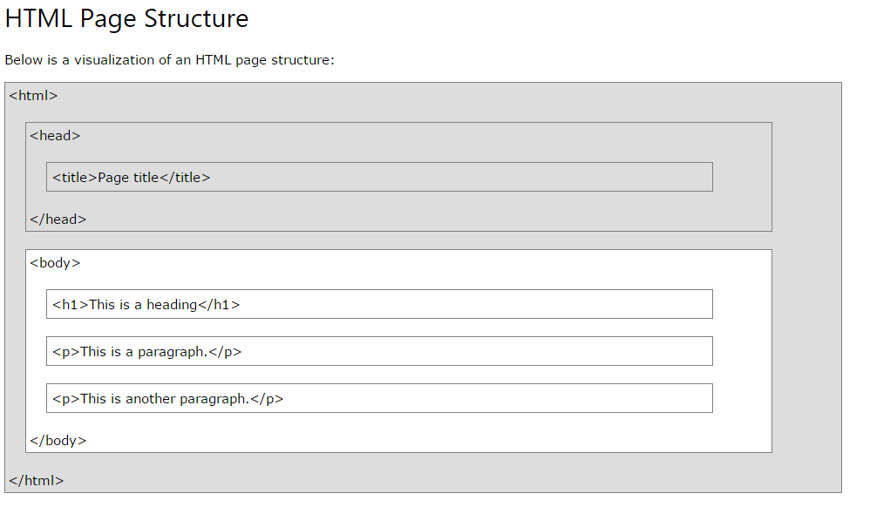

* The **DOCTYPE** declaration defines the document type to be HTML
* The text between **<html>** and **</html>** describes an HTML document
* The text between **<head>** and **</head>** provides information about the document
* The text between **<title>** and **</title>** provides a title for the document
* The text between **<body>** and **</body>** describes the visible page content
* The text between **<h1>** and **</h1>** describes a heading
* The text between **<p>** and **</p>** describes a paragraph

HTML OVERVIEW and PRACTICE

**Basic structure, Headings and Paragraphs**

Step 1: Create a new file called ***question1.html*** and enter the code below.

<!DOCTYPE html>

<html lang="en">

<head>

<meta charset="utf-8">

<title>Page Title goes here</title>

</head>

<body>

<h1> This is a Big Heading</h1>

<h2> This is the next sized Heading </h2>

<h3> Heading size 3.... </h3>

This

text

shows that spaces are ignored

<p> This is a paragraph </p>

</body>

</html>

Save the file and open it in any web browser.

**Images and Line and setting titles**

Step 2: Create a new file called ***question2.html*** and enter the code below.

<!DOCTYPE html>

<head>

<title> Minding Money</title>

</head>

<body >

<h1> How to save money </h1>

<h2 > Calculating you expenses</h2>

<img src="money1.jpg" alt="Picture of Money" width="304" height="204" >

<br/>

<hr/>

<p title="necessary">Step 1</br>

</hr>

Calculating how much we spend monthly, weekly or even daily and what we spend it on, gives a clear picture of our priorities when it comes to money.</br>

</hr>

search on <a href="http://www.google.com">google</a> for more ways to save!!! </p>

<hr/>

</body>

</html>

Save the file and open it in any web browser.

**Revision exercise 1: In groups of two create a home page to a website that describes one thing you and your group partner have in common (It can be a game, a book, sport etc).**

**It must have:**

A Page title followed by a horizontal line,

Then a heading for the topic (for example “World of Warcraft”). You must then find an appropriate picture from online (just for use in this lab) and insert it anywhere you see fit.

Write a brief paragraph (minimum 2 to 3 lines) explaining why you enjoy or love the topic

**CSS BASICS**

Step 3:Create a new file called ***question3.html*** and enter the code below.

<!DOCTYPE html>

<head>

<title> Minding Money</title>

<style>

h1{ color:green; text-align:center}

h2{ color:Blue}

body{background-color:lightgrey}

</style>

</head>

<body >

<h1> How to save money </h1>

<h2 > Calculating you expenses</h2>

<img src="money1.jpg" alt="Picture of Money" width="304" height="204" >

<br/>

<hr/>

<p title="necessary">Step 1</br>

</hr>

Calculating how much we spend monthly, weekly or even daily and what we spend it on, gives a clear picture of our priorities when it comes to money.</br>

</hr>

search on <a href="http://www.google.com">google</a> for more ways to save!!! </p>

<hr/>

</body>

</html>

**You can use the “class” and “id” descriptors to identify sections to change in the CSS**

Step 4: Create a new file called ***question4.html*** and enter the code below.

<!DOCTYPE html>

<html lang="en">

<head>

<meta charset="utf-8">

<title>How to make a drink</title>

<style>

h1.drink{color:green;

text-align:center

}

#description1{

color:red;

}

</style>

</head>

<body>

<h1 class="drink"> Mocha Caffe Latte </h1>

<p id="description1"> Expresso, steamed milk and chocolate syrup, just the way you like it</p>

<br/>

<h1 class="drink"> Iced Tea </h1>

<p id="decription2"> Draw the tea, add ice and sweeten to taste</p>

</body>

</html>

**Borders**

Step 5: Create a new file called ***question5.html*** and enter the code below.

<!DOCTYPE html>

<html>

<head>

<style>

p.dotted {border-style: dotted;}

p.dashed {border-style: dashed;}

p.solid {border-style: solid;}

</style>

</head>

<body>

<h2>The border-style Property</h2>

<p>This property specifies what kind of border to display:</p>

<p class="dotted">A dotted border.</p>

<p class="dashed">A dashed border.</p>

<p class="solid">A solid border.</p>

<p class="dotted">Some sample text with a dotted border.</p>

<p class="dashed">Once the class property is set, the border style and other attribues in the css will be applied as outline.</p>

<p class="solid">Another example.</p>

</body>

</html>

**Using external style sheets**

Step 6:Part 1: Create a new file called ***question6.html*** and enter the code below.

<!DOCTYPE html>

<head>

<title> Minding Money</title>

<link rel="stylesheet" href="stylesheet.css">

</head>

<body >

<h1> How to save money </h1>

<h2 > Calculating you expenses</h2>

<img src="money1.jpg" alt="Picture of Money" width="304" height="204" >

<br/>

<hr/>

<p title="necessary">Step 1</br>

</hr>

Calculating how much we spend monthly, weekly or even daily and what we spend it on, gives a clear picture of our priorities when it comes to money.</br>

</hr>

search on <a href="http://www.google.com">google</a> for more ways to save!!! </p>

<hr/>

</body>

</html>

Part 2: Save the following code in stylesheet .css and refresh the webpage

body {

background-color: lightgrey;

}

h1 {

color: blue;

}

p {

color:green;

}

Save the following code in stylesheet1 .css , change the name in the html code and refresh the webpage

body {

background-color: blue;

}

h1 {text-align:center;

color: Green;

}

p {

color:red;

}

**Revision exercise 2: In groups of two use an external stylesheet with at least 5 elements (research if needed) to standardize your home page. Create two(2) new personal webpages, one for each member that has your name, id number and a brief description about yourself. Link these two pages to the home page and vice versa.**

JAVASCRIPT

**Javascript example 1**

Step 7:Part 1: Create a new file called ***question6.html*** and enter the code below.

<!DOCTYPE html>

<html lang="en">

<head>

<meta charset="utf-8">

<title>Just a Generic Page</title>

<script>

setTimeout(wakeUpUser, 5000);

function wakeUpUser() {

alert("Are you going to stare at this boring page forever?");

}

</script>

</head>

<body>

<h1>Just a generic heading</h1>

<p>Not a lot to read about here. I'm just an obligatory paragraph living in

an example in a JavaScript. I'm looking for something to make my life more

exciting.</p>

</body>

</html>

**Javascript example 2**

Step 8:Part 1: Create a new file called ***question6.html*** and enter the code below.

<!DOCTYPE html>

<html lang="en">

<head>

<meta charset="utf-8">

<title>How to build a House brick by brick</title>

</head>

<body>

<h1>Building a House</h1>

<p>we are going to build the first wall.</p>

<br/>

<hr/>

<script>

document.write("<h1> Laying bricks </h1>");

var count = 0;

while (count <=10){

document.write("Laying brick number "+count+"... <br/>");

document.write("Add some motar... <br/>");

count++;

}

document.write(" Whew!!! laying 10 bricks is tiring!!!!");

</script>

<p>

</p>

</body>

</html>

**Lab Question :**

Carefully analyze the code above and create a webpage that uses javascript to display the 11 times tables in the format.

**1 X 11 = 11**

**2 X 11 = 22**

**3 X 11 = 33**

**….**

**12 X 11 = 132**

**Final exercise: In groups of two create one final page that uses Javascript to generate or create any activity of choice. You must make use of the setTimeout , alert and document.write functionality.**